American Education is Flawed

According to the Pew Research Center <http://www.pewresearch.org/fact-tank/2017/02/15/u-s-students-internationally-math-science/> the American education lags behind many other nations internationally. In fact, for Science, Mathematics, and Reading the United States ranked 22nd, 36th, and 22nd, respectively in 2017 for 15-year-olds. Why in a country that has some of the world’s best universities, does the primary and secondary education fall so short? What are we doing wrong that should be addressed? Let me offer my two cents.

You might be thinking, what does this guy who posts random things on the internet know about education? Well, the short answer is not much formally. But I was a pretty good student growing up – straight A’s through high school and undergraduate. And I will say that the biggest reason why I did so well is that I have a somewhat photographic memory and can memorize information in the short term very well. On the contrary, on year-end standardized tests and cumulative finals I did not do as one might guess based on my other test scores.

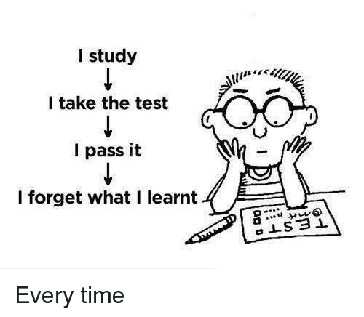

So what does this tell us? Our methods of education emphasize short term information memorization over long term information understanding. Anyone can memorize a list of facts the night before a test, and then completely forget that information 20 minutes after leaving the classroom and ace the course. Think back to your education for a moment. There’s a bunch of big tests that cover vast amounts of information, with some homework assignments in the middle graded for completion.

This problem is even worse in college, where in most classes the majority of your grade comes from two or three midterms, with a small proportion coming from homework / participation. The goal of education is to learn and retain information so that it can be applied later in life. By using a method of evaluation that rewards short term memorization rather than long-term retention, American education has subverted the true intention. It is no wonder that I frequently have a hard time recalling information for a final, let alone trying to remember even a year later. How would you do on your college tests one year after you originally took them?

Current education uses a few tests that cover a large amount of material. This means that a few (maybe even one) questions are used to evaluate a student’s knowledge of a topic. This opens grades up to a lot of variance and unnecessary chance. Maybe that question is something you didn’t study so well, you have a temporary mental block, or it is not representative of whether you know that topic or not.

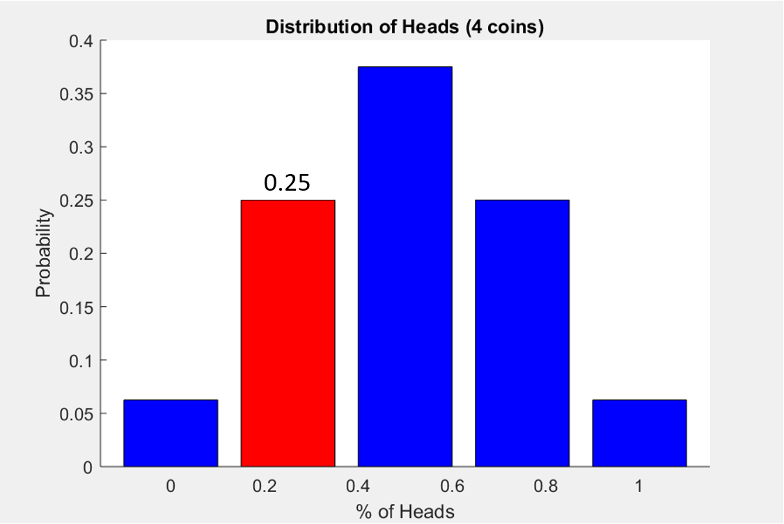

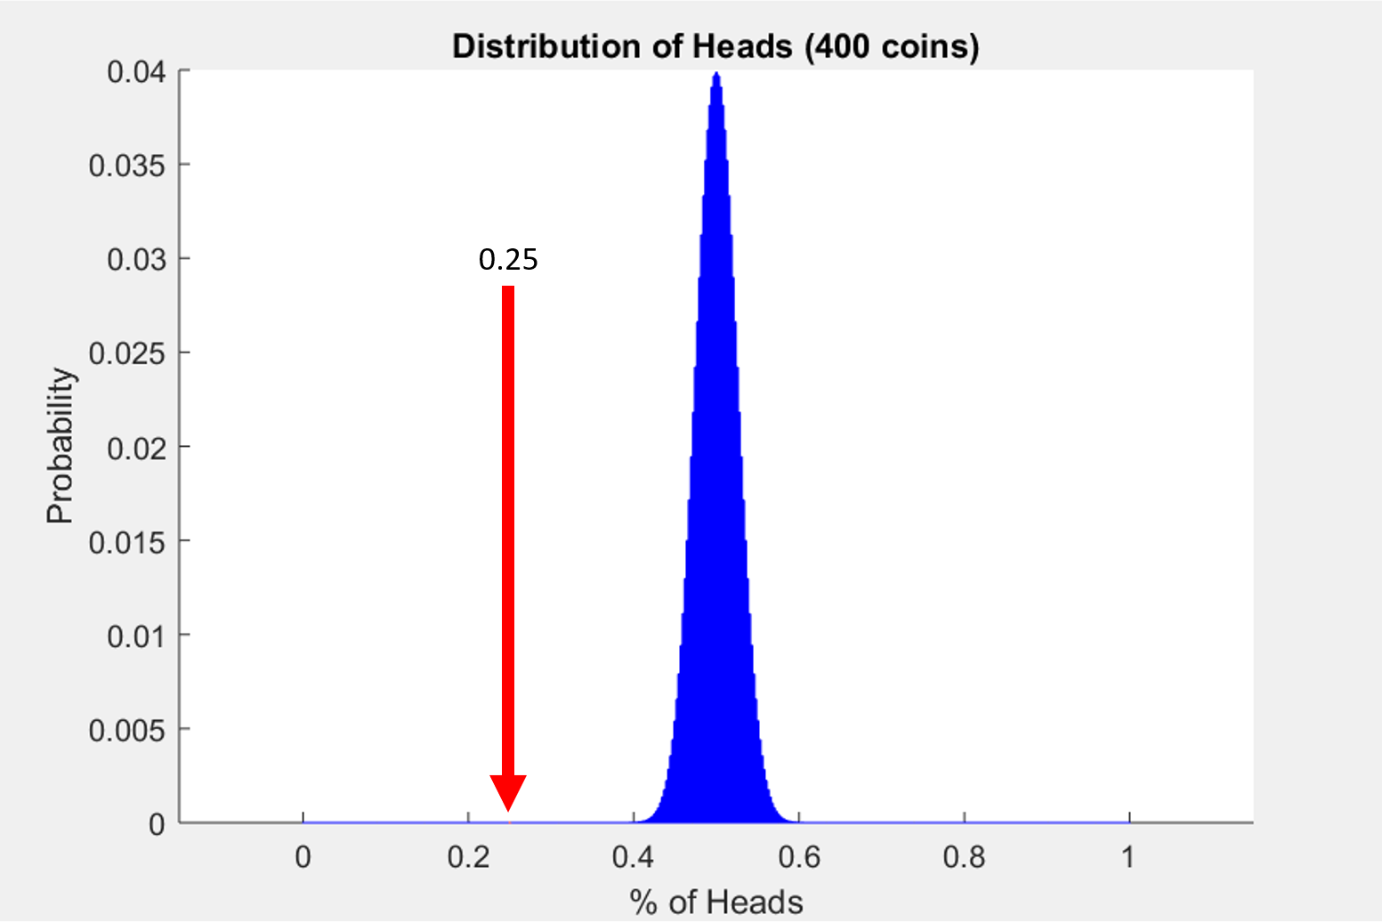

Segway to math: there’s actually a mathematical reason why this makes sense. It is called the “Law of Large Numbers” and the simplest analogy is coin flips. Imagine flipping 4 coins and there is 1 head and 3 tails. Now based off of this, is it fair to make the claim, “well since 25% of the results were heads, the probability of heads for that coin is 25%”? No, of course not. But if you flipped the same coin 400 times and 100 came up heads and 300 came up tails, then you might start to believe that. The idea is that when you take a small sample size, the variance in your results is higher. The more coin flips, the more confident you can be that your results are the true probability of heads.

Thus, there should be an ample number of questions (like having more coin flips) about each topic so that a more complete representation of a student’s knowledge is tested and evaluated. In this way grades would more accurately reflect how well a student has learned the material taught. I advocate for weekly quizzes that thoroughly test the material covered in the previous week. Furthermore, if you continually retest previous material in these weekly quizzes, it encourages long-term knowledge retention versus short-term memorization.

This education methodology would also benefit the student, by taking so much pressure off of having a few large tests count for such a large amount of the final grade. One mess up can cause irreversible damage to your ability to get a good grade in a class. Instead, these more frequent quizzes would be less daunting and count toward a smaller percent of the final grade. So let’s make education do what education was meant to be: flip as many coins as you possibly can.

